Dear Parents and Guardians,
WELCOME to ANT’s Spring Quarter! Thank you for entrusting your wonderful children to our care. It is our great privilege to walk beside our participants as they discover their inner strengths. We are looking forward to deepening connections with returning youth and getting to know wonderful ‘new kids’ as well this Spring.
Spring Quarter runs the week of April 8th through the week of June 3rd, nine weeks. We are closed on federal holidays.
Absences: If your child is going to be absent from a session, please call us no later than two hours before the session time. The office number is (360) 671-3509. There is no opportunity to make up missed days. Two unexcused sessions may cause your child to lose their spot in the quarter and may affect future scholarship opportunities. If you cannot realistically commit to an 9-week session, we may ask that you enroll in the next quarter.
Attendance: Please treat ANT sessions like a doctor or therapy appointment. Be on time and be consistent. We have a waitlist here at the farm and want to ensure that enrolled families are committed to these sessions as these spots are valuable.
Youth that come to the farm consistently are better able to build healing relationship with their horse and will get the most out of this program. If your child is resistant to coming because they had a bad day, those are truly the best days to come to the farm. Please do not let a bad day at school interrupt this important process.
The work we do in our groups is affected by youth missing sessions. We build lessons upon each other and work with your youth on their skills for handling emotions and social situations. Please do not use missing a session at ANT as a negative consequence for a youth’s misbehavior at home or school. We find that most youth actually are better able to manage themselves at home or school if they are attending each week.
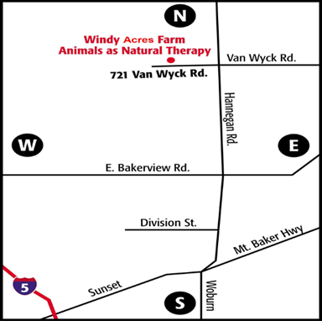
Directions:
As you head west on Van Wyck, the road will split, go straight onto the gravel road, slowing to 10 MPH. If you have paperwork to drop off, you can stop at the Office—through the sliding door of the white house with blue roof (there’s green sign).
To drop off your youth, continue past the white house, past the white garage, along the fencing that has painted wooden horses on it. Turn right down the little driveway into the parking lot. There is a small path leading to a white door in the tall red barn—This is our Meeting Room where our groups begin and end! We will walk youth out to the parking lot at the end of our sessions.

Guidelines for successful participation:
- Please feed your child high-protein and low/no sugar snacks after school to help give them energy for successful participation in the session.
- We have rubber boots, cowboy boots, and helmets available for youth.
- We spend our time outside or in unheated spaces. Weather can change rapidly this time of year. Please send youth with layers of clothing. We have some to loan, but youth usually prefer their own.
- Please have youth wear socks that cover the ankle to prevent painful boot rub (if you have them). Long pants are best for the same reason.
- This is a drop off program. You are welcome to walk your child in to the group and stay with them as they get comfortable at first if needed. However, we do not expect family members to stay for the sessions.
- We request that parents not stay on ANT property or driveways during sessions. You are welcome to stay in your car in the parking lot. Program time is private time for youth to challenge themselves and explore possibilities without outside observation.
- There is limited parking, please be considerate and park only in the designated area behind the arena for drop off and pickup.
- Please don’t drop off more than 5 minutes before start of session. Please pick them up on time. We just have the one room and we need it to debrief afterwards.
- 10 minute parking for paperwork drop-off or payments is available near the office, under the tree house. ANT office hours are 10-4:30pm.
- The Speed limit on the entire gravel drive into the farm is 10 MPH, it may be slower when dusty conditions warrant it.
- Please leave your pets at home. Note also that Windy Acres is a non-smoking facility.

The Family Session will be the 7th week of the quarter. One or two adult family members are invited to join your youth’s session to experience beside your youth and alongside the animals just what they are learning. This can be quite important for your youth so please make every attempt to join us that day.
Again, thank you for giving us the honor of coming to know and learn with your youth.

In gratitude,
Katie Rohwer
Program Coordinator
program@animalsasnaturaltherapy.org
(360) 671-3509

